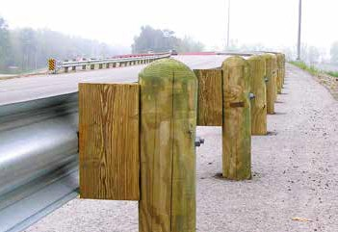
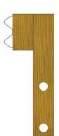
GU ARDR AIL PR ODUCT S

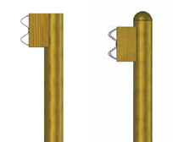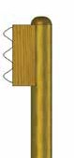Wood Guardrail Posts and Blocks

As the leading manufacturer of wood guardrail posts in North America and stocking locations across the US, our supplier's state of the art manufacturing facilities are able to produce nearly all post and block specifications from Federal to State requirements even though they vary significantly.
Southern Yellow Pine is primarily used which meets AASHTO M-168 for the physical and strength characteristics. Their primary CCA treatment complies with the requirements of AASHTO M-133 preservations as well and we can offer other treatments like, ACQ, Creosote, Pentachlorophenol or nearly any other AWPA, FHWA and state specifications that may be required.
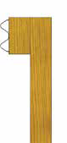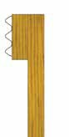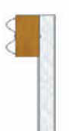Quality control testing on treatment is constant to provide required certifications and documentations necessary for projects across America. As members of the American Traffic Safety Association, they have even gone to lengths of developing their own full scale pendulum crash test facility to analyze our new products for safety and effectiveness.

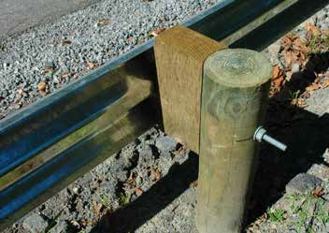
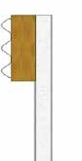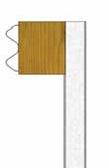

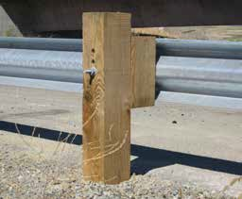
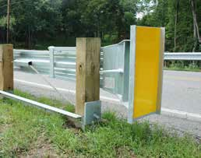
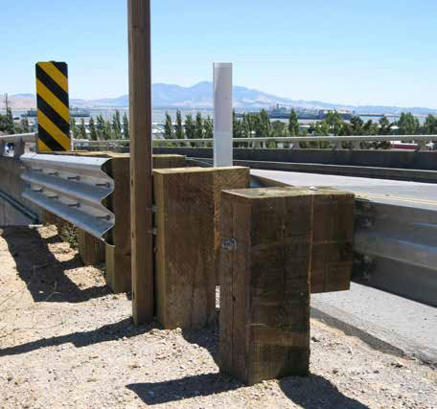
W OOD PRODUCTS

State Spec Wood Product Availability
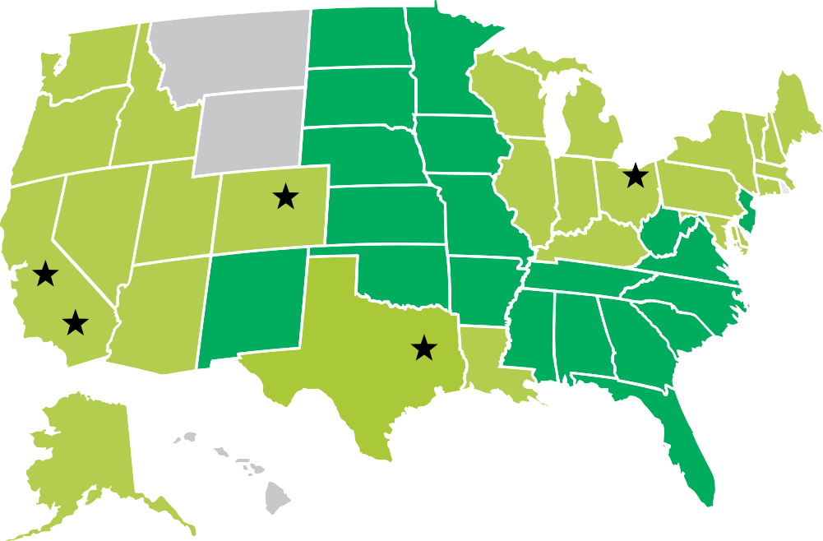

MOST ITEMS READY TO SHIP STANDARD ITEMS READY TO PRODUCE REGIONAL STOCKING YARDS

GU ARDR AIL PR ODUCT S

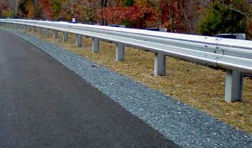
Steel Guardrail Components

In addition to wood products, Gulf Coast Packagers carries a full line of steel guardrail and all the hardware and fasteners needed to complete guardrail system installations.
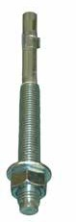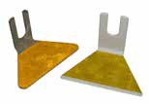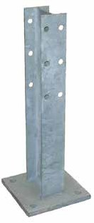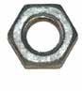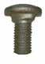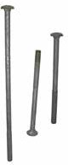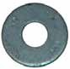We handle 10 Ga. and 12 Ga. Galvanized, as well as, weathering Corten Steel Guardrail and end treatment terminals. All of our Steel Guardrail Components are made in America and they pass all Department of Transportation Standard Specifications.
M
N
O
P
Q
R
S
T
U
V

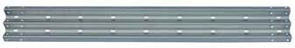
A
B
C
D

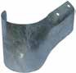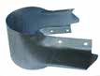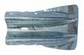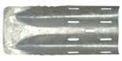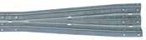
E
F
G
H
I

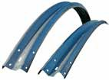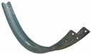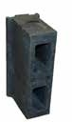
J
K
L

All of our Steel Guardrail Components are made in America and they pass all Department of Transportation Standard Specifications.

Domestic Steel Guardrail Components

Item # | Lbs. Ea. | Description
A FHWB250-0200 | 179.00 lbs. | 25’ | Galv. W-Beam Guardrail 6’ 3” Post Spacing
B FHWB126-0200 | 92.00 lbs. | 12’ 6” | Galv. W-Beam Guardrail 6’ 3” Post Spacing
C FHTB126-0200 | 145.00 lbs. | 12’ 6” | Galv. Thrie-Beam Guardrail
D FHWB126-0400 | 92.00 lbs. | 12’ 6” | 12 Ga. Corten W-Beam Guardrail 6’ 3” Post Spacing
E FHWBHW1-0200 | 23.00 lbs. |  | Galv. W-Beam Guardrail Half Wrap End
F FHWBFW1-0200 | 42.00 lbs. |  | Galv. W-Beam Guardrail Full Wrap End
G FHWBFE1-0200 | 18.60 lbs. |  | Galv. W-Beam Guardrail Flared End
H FHWBESO-0200 | 15.00 lbs. |  | Galv. W-Beam Guardrail Bridge Shoe
I FHTR126-0200 | 61.00 lbs. | 6’ 3” | Galv. W-Beam To Thrie-Beam Transition Rail
J FHWBXXR-0200 | 92.00 lbs. | 12’ 6” | Galv. W-Beam Radius (XX) Guardrail Convex
K FHWBXXR-0201 | 92.00 lbs. | 12’ 6” | Galv. W-Beam Radius (XX) Guardrail Concave
L FH06081-4001 | 14.00 lbs. | 6” X 8” - 14” | Composite Block (Steel Post)
M FHI8530-6200 | 46.50 lbs. | 30” W 6 X 8.5# | Galv. Steel W-Beam Pedestal Post
N FHI8572-6200 | 51.00 lbs. | 6’ W 6 X 8.5# | Galv. Steel W-Beam Post
O FHI8584-6200 | 59.50 lbs. | 7’ W 6 X 8.5# | Galv. Steel Thrie-Beam Post
Domestic Steel Guardrail Hardware

Item # Lbs. ea. Description

P | FH58125-2100 | 0.194 Lbs. | 5/8” - 11 X 1 1/4” | Galv. Splice Bolt
Q | FH58020-2100 | 0.250 Lbs. | 5/8” - 11 X 2” | Galv. Post Bolt (Steel Post And Steel Block)
Q | FH58100-2100 | 0.827 Lbs. | 5/8” - 11 X 10” | Galv. Post Bolt (Steel Post And Wood Block)
Q | FH58180-2100 | 1.392 Lbs. | 5/8” - 11 X 18” | Galv. Post Bolt (Wood Post And Wood Block)
R | 4934850-9909 | 1.050 Lbs. | 3/4” - 10 X 8 1/2” | Concrete Post Anchor
S | FH58000-8200 | 0.175 Lbs. | 5/8” - 11 | Galv. Double Recessed Nut
T | FH58000-6200 | 0.078 Lbs. | 5/8” | Galv. Flat Washer
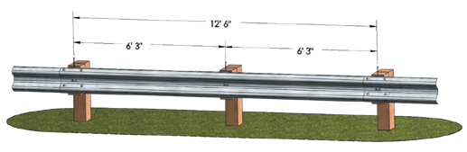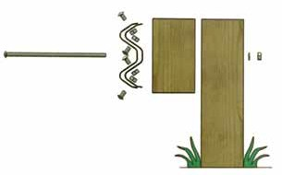

Powder Coated Guardrail

Powder coating over the same heavy duty, 12 gauge galvanized rails and components used in highway construction will add years of service life and assist in protection any where needed. Designed to withstand crashes with a pickup truck at 55 MPH may be more than required but will save you money over other systems.
Many businesses are showing off their company colors with vibrant Powdered Coated Guardrail of their corporate theme in their parking lots or buildings. The yellow color is perfect for high visibility and safety. While the green and brown colors are great for parks and scenic roadways by blending in rather than the standard silver guardrail.

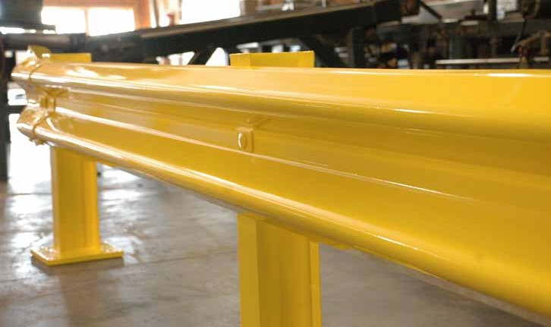

Expert assistance is only a
phone call away.
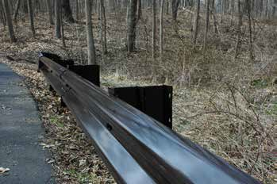
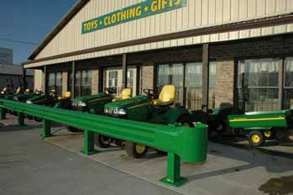

TIMBERS

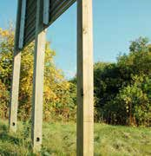
Sign Posts

Our supplier's Texas and Ohio locations manufacture our Wood Sign Posts from Texas grown Southern Yellow Pine and then treat to .60 CCA meeting the American Wood Protection Association standards.
Our Sign Posts range in size from 4x4-8’ through 6x8-28’ with many sizes in stock and can be pre- drilled with bolt holes and/or breakaway holes for faster installation time.

Box Beam Sign Posts

For a very strong and large sign post, GCP's supplier also manufactures Box Beam Posts utilizing layers of veneer, glued together into long panels. They are available as 8x8’s and 8x15’s up to 40 feet long and are easily field drilled and cut in order to be utilized as break- away supports.
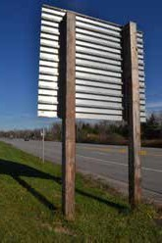
The box beams are then treated with a Light Pentachlorophenol Type C to .50 retention meeting the American Wood Protection Association standards before they are stained and sealed to a very rich brown
8” X 8” Box Beam Sign Posts .50 Penta Type C

8” x 8” | 8” x 15”
Lgth. Item # Lbs. ea | Item # Lbs. ea
20’ 0808208-6S06 253.00 lbs
22’ 0808228-6S06 278.30 lbs.
24’ 0808248-6S06 303.60 lbs. | 0814248-6S06 461.25 lbs.
26’ 0808268-6S06 328.90 lbs. | 0814268-6S06 499.60 lbs.
28’ 0808288-6S06 354.28 lbs. | 0814288-6S06 538.11 lbs.
30’ 0808308-6S06 379.59 lbs. | 0814308-6S06 576.50 lbs.
32’ 0808328-6S06 404.90 lbs. | 0814328-6S06 615.00 lbs.
34’ | 0814348-6S06 653.44 lbs.
36’ | 0814368-6S06 691.87 lbs.
38’ | 0814388-6S06 730.30 lbs.
40’ | 0814408-6S06 768.75 lbs.

Microllam® LVL Breakaway Signpost

tone.
Type M Post

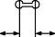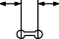TYP
8”
8”
Type L Post

TYP

TREATED WEIGHT 14 LBS. PER FT.

8”

3” 3”

3” 3”
3”

1” HOLES, WITH SAW CUT BETWEEN
(TYP BOTH SIDES)
18”
18”

15”

5” 5”

3” 3”
3”

TREATED WEIGHT 17 LBS. PER FT.

TYPE M POST TYPE L POST

HARD W ARE

Fasteners
The fasteners listed are stocked as imported hot dipped galvanized but we also have many options for stainless steel and domestic fasteners.

Hot Dipped Galvanized Hex Head Bolts ”A”

Please call for pricing and availability.

Hot Dipped Galvanized Lag Bolts ”C”

Size | 5/16” | 3/8” | 1/2” | 5/8” | 3/4” |  | Size | 1/4” | 5/16” | 3/8” | 1/2”
3” | Stocked | Stocked | Stocked | Stocked | Stocked |  | 3” | Stocked | Stocked | Stocked | Stocked
3 1/2” | Stocked | Stocked | Stocked | Stocked | Stocked |  | 3 1/2” | Stocked | Stocked | Stocked | Stocked
4” | Stocked | Stocked | Stocked | Stocked | Stocked |  | 4” | Stocked | Stocked | Stocked | Stocked
4 1/2” | Stocked | Stocked | Stocked | Stocked | Stocked |  | 4 1/2” | Stocked | Stocked | Stocked | Stocked
5” | Stocked | Stocked | Stocked | Stocked | Stocked |  | 5” | Stocked | Stocked | Stocked | Stocked
6” | Stocked | Stocked | Stocked | Stocked | Stocked |  | 6” | Stocked | Stocked | Stocked | Stocked
8” |  | Stocked | Stocked | Stocked | Stocked
10” |  | Stocked | Stocked | Stocked | Stocked
12” Stocked Stocked Stocked Stocked |  |  |  |  |  | Hot Dipped Galvanized Flat Washers ”D”

3” | Stocked | Stocked | Stocked | Stocked | Stocked | 5/16” |  | 3/8” | 1/2” | 5/8” | 3/4”
3 1/2” | Stocked | Stocked | Stocked | Stocked | Stocked
4” | Stocked | Stocked | Stocked | Stocked | Stocked | Nuts Stocked Stocked Stocked Stocked Stocked
4 1/2” | Stocked | Stocked | Stocked | Stocked | Stocked
5” | Stocked | Stocked | Stocked | Stocked | Stocked
6” | Stocked | Stocked | Stocked | Stocked | Stocked | Hot Dipped Galvanized Pole Barn Spikes “F”
8” | Stocked |  | Stocked | Stocked | Stocked
10” | Stocked |  | Stocked | Stocked | Stocked | 4” | 5” | 6” | 8” | 10” | 12”
12” | Stocked |  | Stocked | Stocked | Stocked

14” Stocked Stocked Stocked
16” Stocked Stocked
Stocked Stocked Stocked Stocked Stocked Stocked

14” | Stocked |  |  | Stocked | Stocked
16” | Stocked |  |  | Stocked | Stocked | 5/16” | 3/8” 1/2” 5/8” | 3/4”
Washers Stocked Stocked Stocked Stocked Stocked
Hot Dipped Galvanized Carriage Bolts ”B”
Size | 5/16” | 3/8” | 1/2” | 5/8” | 3/4” | Hot Dipped Galvanized Hex Nuts ”E”

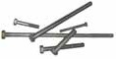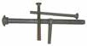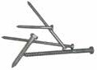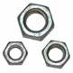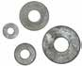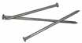
A
B
C
D
E
F

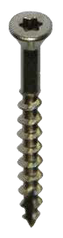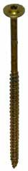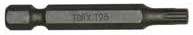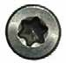Stainless Steel Star Drive Screws - ACQ Approved
A
B
C
D
E

Size | Description | Driver Size
1 5/8” | #7 SS Trim Star Drive Screw | T15 | Stocked | A
2 1/4” | #7 SS Trim Star Drive Screw | T15 | Stocked | A
1 5/8” | #9 SS Star Drive Screw | T25 | Stocked | B
2” | #9 SS Star Drive Screw | T25 | Stocked | B
2 1/2” | #10 SS Star Drive Screw | T25 | Stocked | B
3” | #10 SS Star Drive Screw | T25 | Stocked | B
3 1/2” | #10 SS Star Drive Screw | T25 | Stocked | B
4” | #10 SS Star Drive Screw | T25 | Stocked | B

GRK Fasteners R4 Multi Purpose Star Drive Screws - ACQ Approved

Size | Description | Driver Size
1 1/2” | #8 Trim Star Drive Screw | T10 | Stocked | B
2” | #8 Trim Star Drive Screw | T10 | Stocked | B
2 3/4 | #8 Trim Star Drive Screw | T10 | Stocked | B
1 3/4” | #8 Star Drive Screw | T15 | Stocked | C
2 1/2” | #9 SS Star Drive Screw | T25 | Stocked | C
3 1/8” | #10 SS Star Drive Screw | T25 | Stocked | C
3 1/2” | #10 SS Star Drive Screw | T25 | Stocked | C
4” | #10 SS Star Drive Screw | T25 | Stocked | C

GRK Fasteners Structural Star Drive Screws - ACQ Approved

Size | Description | Driver Size
1/4”x 2 1/2” | Structural Star Drive Screw | T25 | Stocked | D
1/4”x 3 1/2” | Structural Star Drive Screw | T25 | Stocked | D
5/16” x 4” | Structural Star Drive Screw | T30 | Stocked | D
5/16” x 6” | Structural Star Drive Screw | T30 | Stocked | D
3/8” x 4” | Structural Star Drive Screw | T30 | Stocked | D
3/8” x 6” | Structural Star Drive Screw | T30 | Stocked | D
3/8” x 8” | Structural Star Drive Screw | T30 | Stocked | D
3/8” x 10” | Structural Star Drive Screw | T30 | Stocked | D
3/8” x 12” | Structural Star Drive Screw | T30 | Stocked | D
3/8” x 14” | Structural Star Drive Screw | T30 | Stocked | D
3/8” x 16” | Structural Star Drive Screw | T30 | Stocked | D

Star Drive Torx Drivers ”E”

 | T10 | T15 | T20 | T25 | T30
Drivers | Stocked | Stocked | Stocked | Stocked | Stocked

